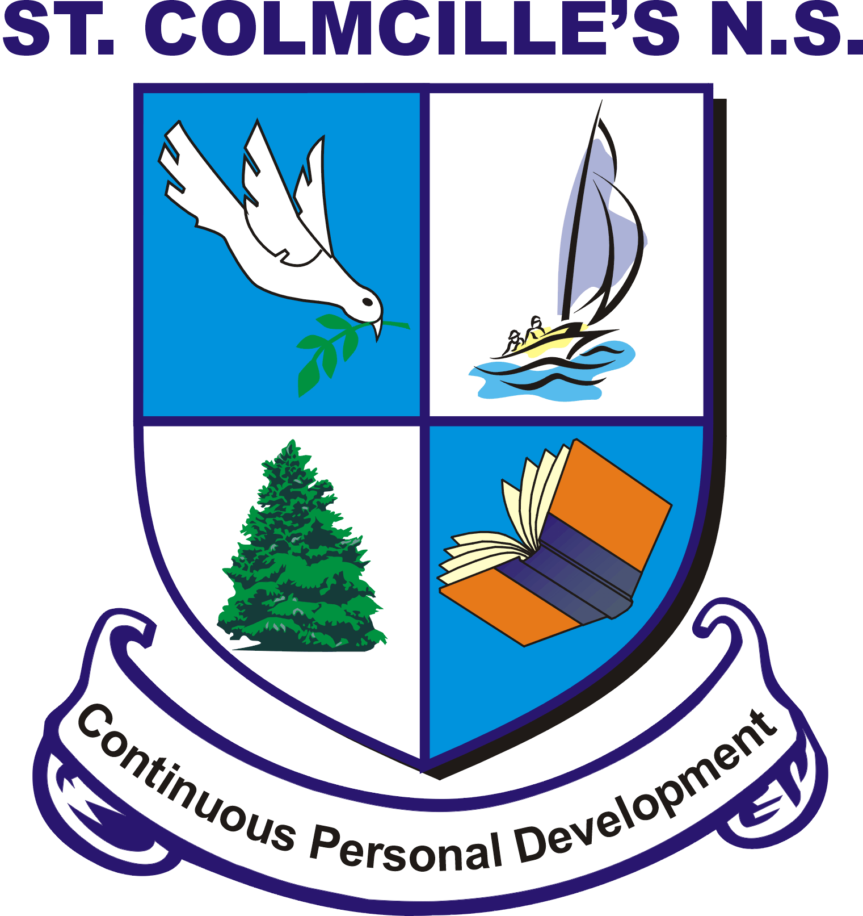
Principal: Thomas Keena St. Colmcille’s N.S.,
Dep. Pr.: Lynda Dunning Ballinahown,
Phone: 090 6430044 Athlone,
E-mail:principalballinahownns@gmail.com Co. Westmeath. Co. Westmeath.
Web: www.ballinahownns.ie

Code of Behaviour
St. Colmcille’s National School has a central role in the children's social and moral
development just as it does in their academic development. In seeking to define
acceptable standards of behaviour it is acknowledged that these are goals to be
worked towards rather than expectations that are either fulfilled or not.

The children bring to school a wide variety of behaviour. As a community
environment, in school we must work towards standards of behaviour based on the
basic principles of honesty, respect, consideration and responsibility. It follows that
acceptable standards of behaviour are those that reflect these principles.

Children need limits set for them in order to feel secure and develop the skills for cooperation. Therefore any rules will be age appropriate, with clear agreed
consequences.

Parents can co-operate with the school by encouraging their children to understand
the need for school rules, by visiting the school and by talking to the members of
staff.

A code of behaviour is established to ensure that the individuality of each child is
accommodated while at the same time acknowledging the right of each child to
education in a relatively disruption free environment.

Aims of the Code

• To create a positive learning environment that encourages and reinforces
good behaviour
• To promote self-esteem and positive relationships
• To encourage consistency of response to both positive and negative behaviour
• To foster a sense of responsibility and self-discipline in pupils and to support
good behaviour patterns based on consideration and respect for the rights of
others
• To facilitate the education and development of every child
• To foster caring attitudes to one another and to the environment
• To enable teachers to teach without disruption
• To ensure that the school's expectations and strategies are widely known and
understood through the parent’s handbook, availability of policies and an
ethos of open communication
• To encourage the involvement of both home and school in the implementation
of this policy

Responsibility of Adults
The adults encountered by the children at school have an important responsibility to
model high standards of behaviour, both in their dealings with the children and with
each other, as their example has an important influence on the children.

As adults we should aim to:

- Create a positive climate with realistic expectations
- Promote, through example, honesty and courtesy
- Provide a caring and effective learning environment
- Encourage relationships based on kindness, respect and understanding of the
Needs of other
- Ensure fair treatment for all regardless of age, gender, race, ability and disability
- Show appreciation of the efforts and contribution of all
- To discourage physical aggression and encourage ‘Kind Hands, Kind Words,
Kind Feet’.

School Rules
• Respect for self and others
• Respect for other’s property
• Respect other students and their learning
• Kindness and willingness to help others
• Follow instructions from staff immediately
• Walk quietly in the school building
• Courtesy and good manners
• Readiness to use respectful ways of resolving difficulties and conflict
• Ask permission to leave the classroom
• Do your best in class
• Take responsibility for your own work
These can be summed up in our school motto
‘ Treat others as you would like them to treat you’ and
• Be Responsible, Be Respectful, Be Kind, Be Honest and Be Your Best

Class Rules
At the beginning of each academic year, the class teacher will draft a list of class
rules with the children. These reflect and support the school rules, but are presented
in a way that is accessible to the children. Class rules should be kept to a minimum
and are devised with regard for the health, safety and welfare of all members of the
school community. They should where possible emphasise positive behaviour (e.g.
‘Walk’ and not ‘Don’t run’). Rules will be applied in a fair and consistent manner,
with due regard to the age of the pupils and to individual difference. Where
difficulties arise, parents will be contacted at an early stage.

Promoting Inclusion In School Yard
As part of our Code of Behaviour we are putting in three systems in place to promote
inclusion in the school yard.

Buddy System : On a rota basis a boy and girl from 5th /6th class spend both
break times in the front yard with the junior classes helping children who are
on their own to find a friend to play with, promoting good behaviour through
their example and helping with games etc. This is done under the supervision
of those adults on supervision duty in this yard.

Buddy Bench : Children who are not having a great day, or need a friend to play with or talk to can sit on a ‘Buddy Bench’, which the children will be encouraged to respond to.

Playground Games – Staff in conjunction with the children in the older classes
will devised a programme of team games to promote
inclusion of all, to encourage teamwork and foster self confidence. Senior class
pupils will be responsible for teaching playground games to groups of younger children.

How we treat each other and speak to each other
As part of becoming a ‘Mindful School‘, we place a huge emphasis and importance on the way we all speak to each other. Whether it be in the classroom, on the school yard or on the sports field, we will strive to promote an exemplary behaviour in how we treat each other and how we look out for one another. We will strive to be sensitive to others feelings, to greet them politely, to learn to lose with dignity, to learn to not always put ourselves first regardless of the rest.
We will encourage respect for the children, their classmates, the staff, their parents , the wider school community and their environment.
We will also reward children for this time of behaviour and try to ‘catch a child behaving respectfully’

Incentives
Part of the vision of St. Colmcille’s is to help children achieve their personal best -
academically, intellectually and socially. We recognise that there are many different
forms of intelligence and that similarly children use a variety of approaches to solve
problems. Reward systems which are based on academic merit or particular
extrinsic goals continuously apply to only a limited number of children and
undermine the individuality of children. All children deserve encouragement to attain
their own best. Children will be encouraged, praised and listened to at all times by
adults in the school. Praise is earned by the maintenance of good standards as well
as by particularly noteworthy personal achievements. Rates of praise for behaviour
should be as high as for work.

The following are some samples of how praise might be given;
• A quiet word or gesture to show approval
• A comment in a pupil’s exercise book
• A visit to another member of Staff or to the Principal for commendation
• A word of praise in front of a group or class
• A system of merit marks or stickers
• Delegating some special responsibility or privilege
• A mention to parent, written or verbal communication.

Positive Behaviour Reward System : Our school runs a stamp reward system in each
class. Rewards are given for good behaviour, neat work in class and out of class, and any other area the class teacher may include.
Having consulted the children and teachers the following reward systems and prizes have been drawn up. Teachers will use these reward systems as best to suit their environment.
Rewards can be at individual, class or whole school level.

Record of Behaviour by : | Rewards : | Rewards :
Dojo points  Marbles  Stamps  Stars  Stickers  Lovely leithreas  Seomra Spotless  Gaeilgeoir na Seachtaine (Monitored)  Scríobhneoir na Coicíse (monitored)  Table of the Week | Golden time  Change of seat  Maths games  Extra time for lunch  Pizza Party  Popcorn Party  Trip to the Park  Movie | Treat Day.  Halloween/ Christmas/ Easter Party  Listen to Music  Homework pass  Trophy for Gaeilgeoir na Seachtaine

Unacceptable Behaviour
Three levels of misbehaviour are recognised: Minor, Serious and Gross. All everyday
instances of a minor nature are dealt with by the class teacher. In cases of repeated
serious misbehaviour or single instances of gross misbehaviour, parents will be
involved at an early stage and invited to meet the teacher and/or the Principal to
discuss their child’s behaviour.

Examples of serious misbehaviour:
• Behaviour that is hurtful (including bullying, harassment, discrimination and
victimisation)
• Behaviour that interferes with teaching and learning
• Threats or physical hurt to another person
• Damage to property
• Theft

Examples of gross misbehaviour:
• Assault on a teacher or pupil
• Serious theft
• Serious damage to property

Sanctions
The use of sanctions or consequences should be characterised by certain features;
• It must be clear why the sanction is being applied
• The consequence must relate as closely as possible to the behaviour
• It must be made clear what changes in behaviour are required to avoid future
sanctions
• There should be a clear distinction between minor and major offences
• It should be the behaviour rather than the person that is the focus

The following steps will be taken when the children behave inappropriately. They are
listed in order of severity with one being for a minor misbehaviour and ten being for
serious or gross misbehaviour. The list is by no means exhaustive. Teachers may
put in place alternative measures bearing in mind the features by which sanctions
should be characterised. The aim of any sanction is to prevent the behaviour
occurring again and if necessary to help the pupils devise strategies for this;

1. Reasoning with pupil
2. Verbal reprimand including advice on how to improve
3. Temporary separation from peers within class and/or temporary removal to
another class
4. Prescribing extra work/ writing out the story of what happened
5. Loss of privileges
6. Detention during break
7. Communication with parents
8. Referral to Principal
9. Principal communicating with parents
10. Exclusion (Suspension or Expulsion) from school (in accordance with Rule 130
of the Rules for National Schools as amended by circular and Education
Welfare Act 2000)

However sanctions should relate as closely as possible to the behaviour. Therefore a
child, who does not do his work in class or has not completed his homework, may, if deemed necessary, be detained at break time to finish the work.
Pupils will not be deprived of engagement in a Curricular Area, except on the
grounds of health & safety.

Suspension and Expulsion
Before serious sanctions such as detention, suspension or expulsion are used, the
normal channels of communication between school and parents will be utilised.
Where it is proposed to detain a pupil after school hours, the parents or guardians
will be notified. Communication with parents may be verbal or by letter depending
on the circumstances.
For gross misbehaviour or repeated instances of serious misbehaviour suspension
may be considered. Parents concerned will be invited to come to the school to
discuss their child’s case. Aggressive, threatening or violent behaviour towards a
teacher or pupil will be regarded as serious or gross misbehaviour.
Where there are repeated instances of serious misbehaviour, the Chairperson of the
Board of Management will be informed and the parents will be requested in writing to
attend at the school to meet the Chairperson and the principal. If the parents do not
give an undertaking that the pupil will behave in an acceptable manner in the future
the pupil may be suspended for a period. Prior to suspension, where possible, the
Principal may review the case in consultation with teachers and other members of
the school community involved, with due regard to records of previous
misbehaviours, their pattern and context, sanctions and other interventions used and
their outcomes and any relevant medical information. Suspension will be in
accordance with the Rules for National Schools and the Education Welfare Act 2000.
In the case of gross misbehaviour, where it is necessary to ensure that order and
discipline are maintained and to secure the safety of the pupils, the Board may
authorise the Chairperson or Principal to sanction an immediate suspension for a
period not exceeding three school days, pending a discussion of the matter with the
parents.
Expulsion may be considered in an extreme case, in accordance with the Rule for
National Schools and the Education Welfare Act 2000. Before suspending or
expelling a pupil, the Board shall notify the Local Welfare Education Officer in writing
in accordance with Section 24 of the Education Welfare Act.

Removal of Suspension (Reinstatement)
Following or during a period of suspension, the parent/s may apply to have the pupil
reinstated to the school. The parent/s must give a satisfactory undertaking that a
suspended pupil will behave in accordance with the school code and the Principal
must be satisfied that the pupil’s reinstatement will not constitute a risk to the pupil’s
own safety or that of the other pupils or staff. The Principal will facilitate the
preparation of a behaviour plan for the pupil if required and will re-admit the pupil
formally to the class.

Children with Special Needs
All children are required to comply with the code of behaviour. However the school
recognises that children with special needs may require assistance in understanding
certain rules. Specialised behaviour plans will be put in place in consultation with
parents and the class teacher, learning support/ resource teacher, and or Principal
will work closely with home to ensure that optimal support is given. Cognitive
development will be taken into account at all times. Professional advice from
psychological assessments will be invaluable.
The children in the class or school may be taught strategies to assist a pupil with
special needs adhere to the rules and thus provide peer support. This will be done in
a supportive and safe way, acknowledging and respecting the difference in all
individuals.

Methods of Communicating with Parents
Communicating with parents is central to maintaining a positive approach to dealing with children. Parents and teachers should develop a joint strategy to address specific difficulties, in addition to sharing a broader philosophy which can be implemented at home and in school.
A high level of co-operation and open communication is seen as an important factor,
encouraging positive behaviour in the school. Structures and channels designed to
maintain a high level of communication among staff and between staff, pupils and
parents have been established and are being reviewed regularly.
Parents should be encouraged to talk in confidence to teachers about any significant
developments in a child’s life, in the past or present, which may affect the child’s
behaviour.
The following methods are to be used at all levels within the school:
• Informal parent/teacher meetings and Formal parent/teacher meetings
• Through children’s homework journal (infants do not have a homework
journal-check bags)
• Letters/notes from school to home and from home to school
• School notice board
• Monthly newsletter

Parents: Roles and Responsibilities
• Equip pupils with appropriate school materials, a sufficient healthy lunch and
full uniform.
• Be courteous towards all pupils and staff
• Make an appointment to meet with a teacher/Principal through the school
office.
• Respect school property and encourage their children to do the same.
• Label pupils coats, uniforms, tracksuits and other property.
• Supervise their young children on school premises when collecting other
pupils or visiting the school.
• As the Board of Management is responsible for the health and safety of all
staff and students, parents are requested not to approach or reprimand
another person’s child on the school premises.

